1. Phys 305, Hw 3, Christopher Morris

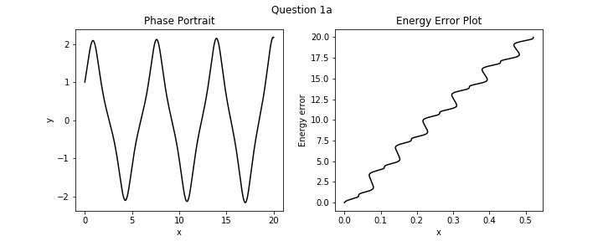

b)

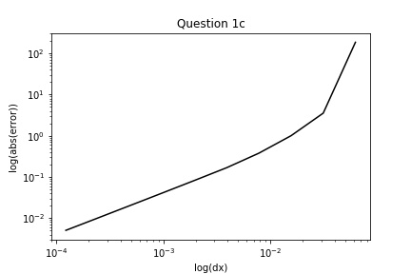

c)

d)

For dt = .01

X = 1.3530843112619095e-16 y = 0.6045765738231577 v = 1.4299590780562876

For dt = .005

X = 6.765421556309548e-17 y = .7954373973101688 v = 1.4521784685313313

For dt = .001

X = 4.510281037539698e-16 y = 0.9578973390261415 v = 1.489686168055795

As dt gets smaller the integrator gets closer to reaching the initial points, so yes the integrator is reversible.

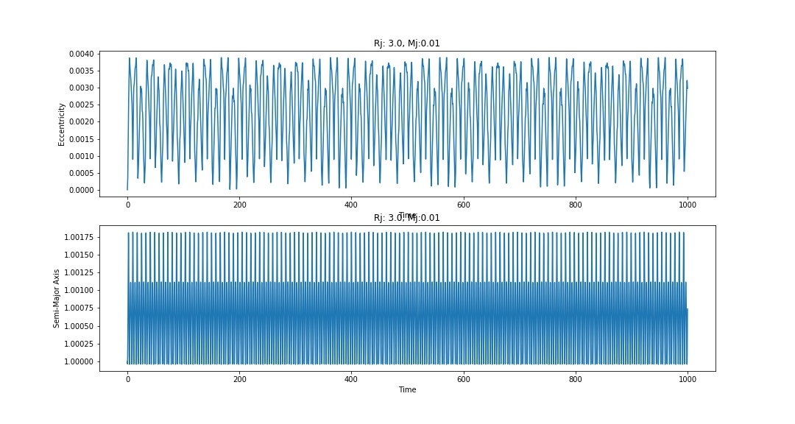2)

Ai

Emax = 0.00388237

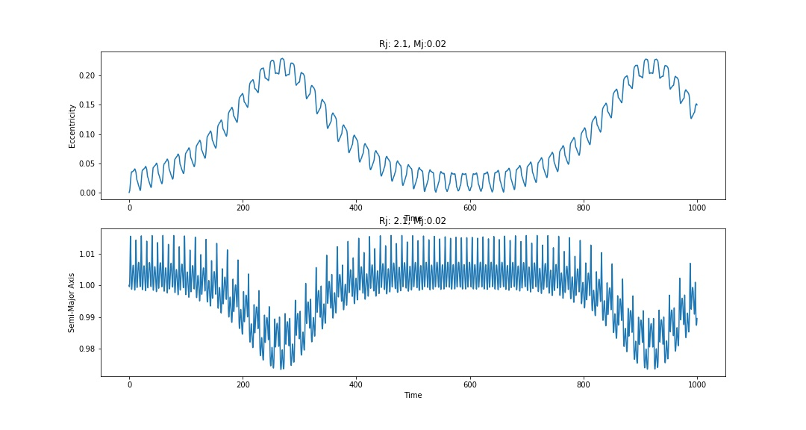

Aii

Emax = 0.229572171

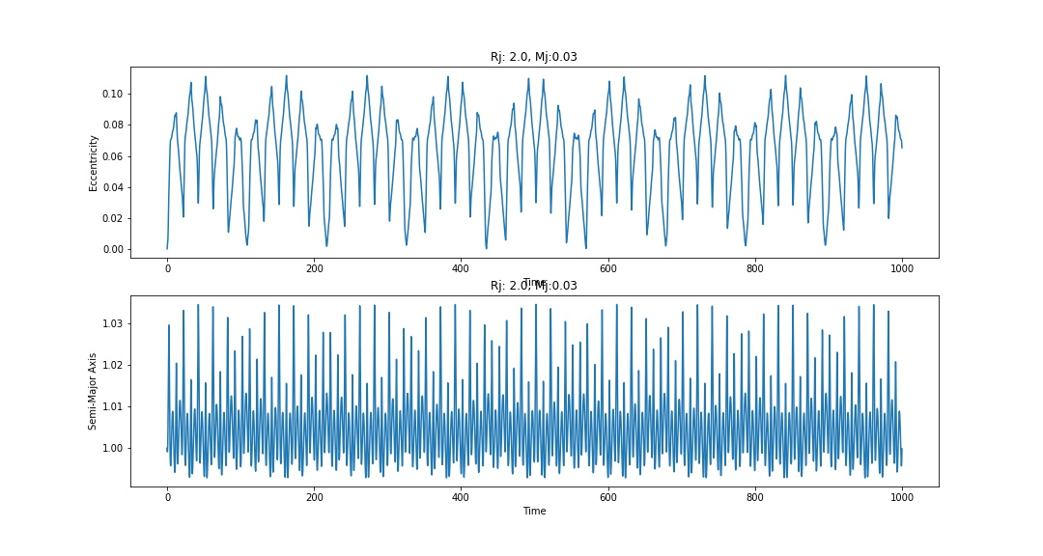

Aiii

Emax = 0.1119758

2)

b)

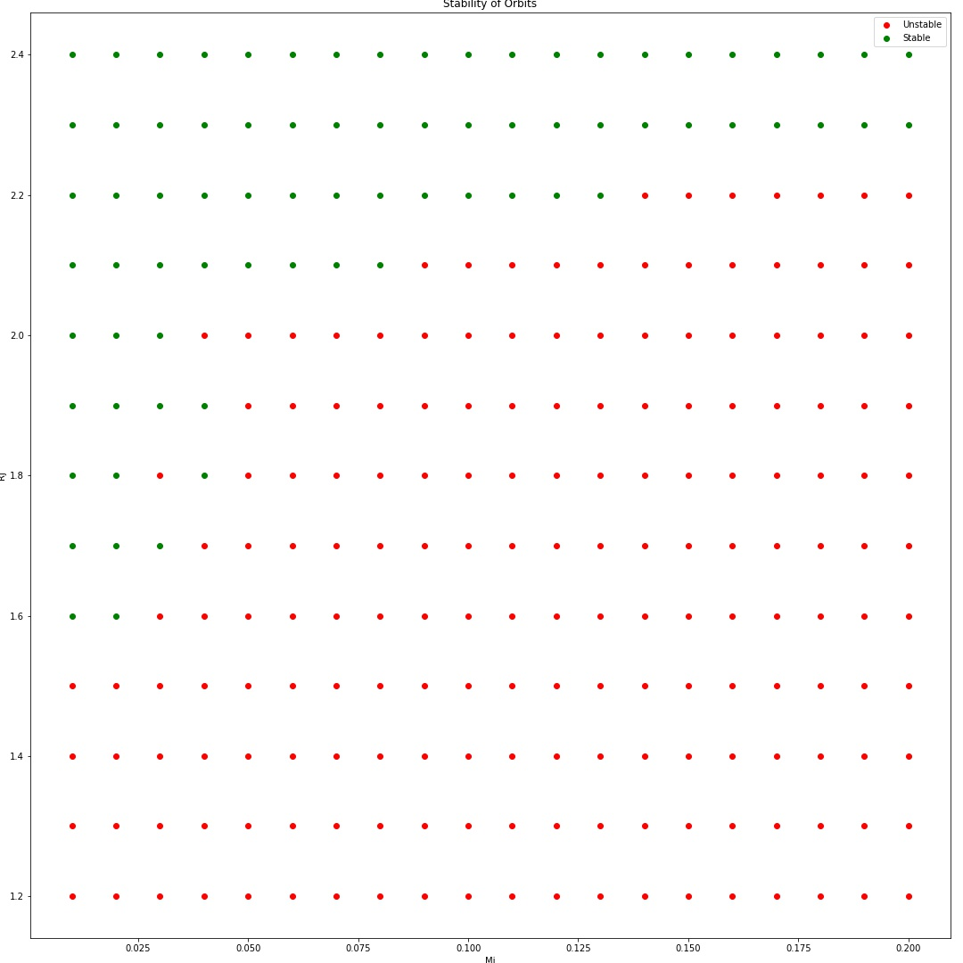

The region of stability is shown to be much smaller than the region of instability.

The regions of stability/instability seem to be divided by the approx. line y = 1.4 + .08x.

However, as the Mj gets larger, the slop decreases slightly; however, a much larger/finer image would have to be made to see.

3)

a)

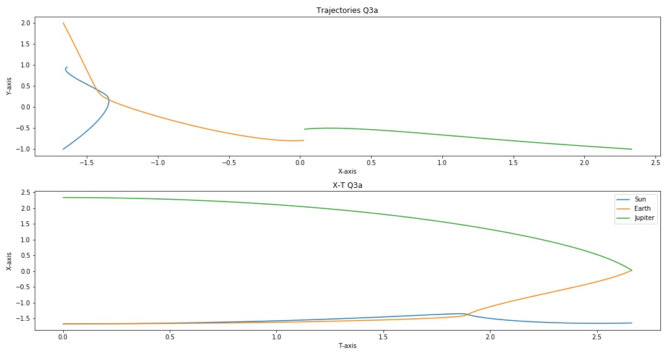

b)

i)

t = .0005

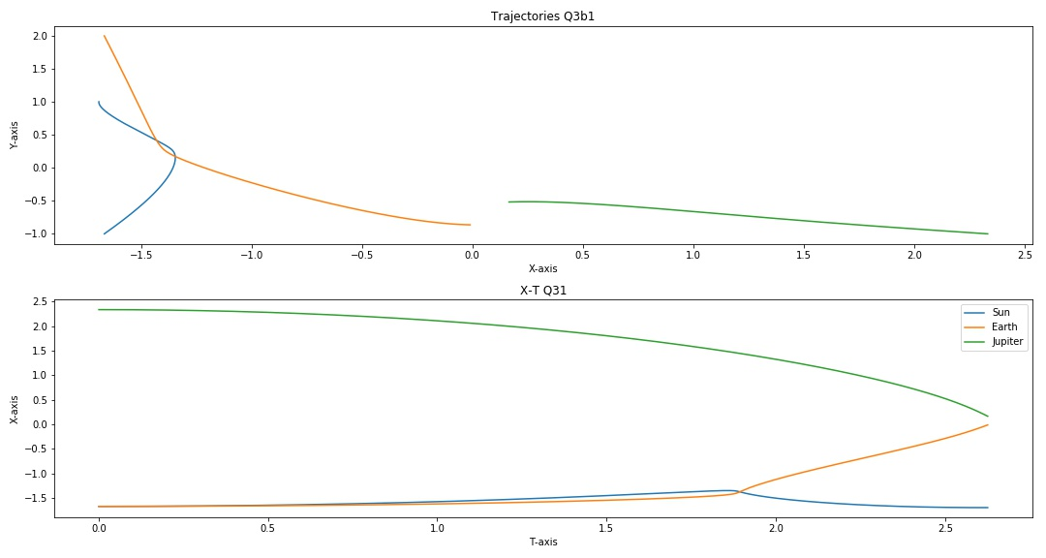

ii)

t = .001

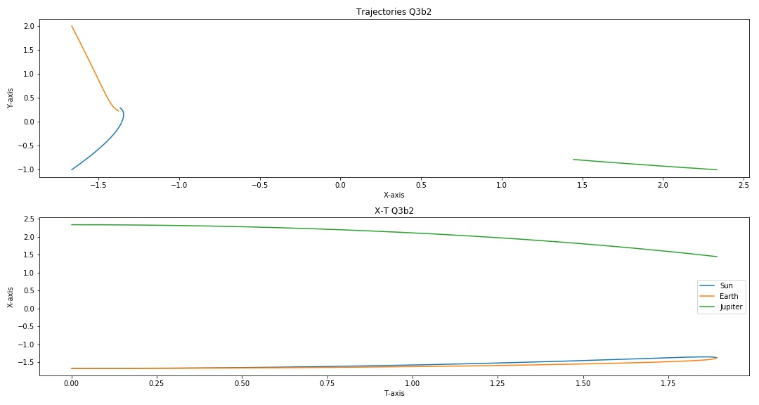

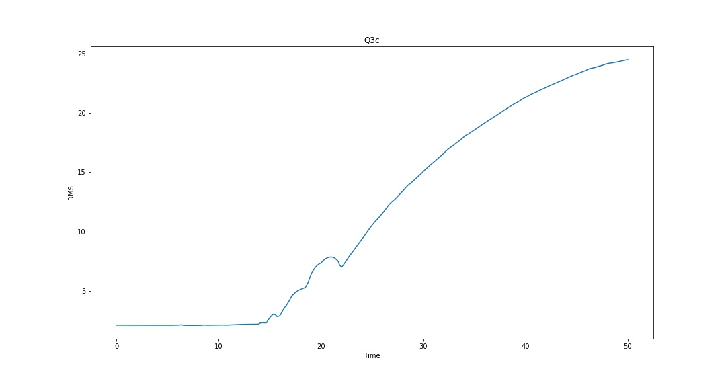c)

The plot shows that as time progresses the deviation between each simulation increases. Up until t = 10 the simulations follow the same path shown by the constant rms due to the chance in y. However, as time increases the simulations start following significantly different path which leads to that sudden increase in rms.